The Society of Mary

FORM OF APPLICATION FOR MEMBERSHIP

To: The Membership Secretary
Mrs Celia Bush, 169 Humber Doucy Lane, Ipswich, IP4 3PA secretary@societyofmary.net

Declaration

I, ____________________________________ (Block letters, full name please) Title ________

declare that I am a member of the Holy Catholic Church and that I conform to her discipline and precepts; I desire to be admitted a MEMBER of the Society of Mary and I PROMISE to fulfil the conditions, promote the objects and keep the rules of the Society.

I enclose my first subscription herewith (minimum £15, or a Life Subscription of £150).

Signed ________________________________________________________________

Address (Block letters please) __________________________________________________

__________________________________________________Post code ____________

Telephone _________________ E-mail _____________________________________
Please ensure that you read the Data Protection Statement
and sign and date the Form of Consent.

Recommendation by a Priest, who should be a member of the Society.

From my PERSONAL knowledge of _____________________________ (Block letters please)
I believe that he/she is suitable to be a member of the Society of Mary.

Date ___________ Name ___________________ Signed _______________________
Parish/appointment ______________________________________________________

Address _______________________________________________________________

______________________________________________________________________

Post Code _________________________ Telephone ___________________________

Ward Applicant wishes to join _____________________________________________

Data Protection Statement

Information given on this form will be used by the Society for membership administration and other purposes connected with the pursuit of the Society’s objectives. For those purposes, it may be passed to the Society’s agents or professional advisers, but it will not be used for any other purpose or divulged to any other person. For the purposes of the Data Protection Act 1998, the Society’s representative is its current Honorary Secretary.
_______________________________________________________________________

Form of Consent

I hereby give my consent to the entry of personal data supplied on this form into the Society’s records, to their being processed by electronic means and to their being passed to the Society’s agents and professional advisers. This consent is given on the understanding that the data involved will be used by the Society only for purposes connected with the administration of the Society.

Signed _________________________________ Date __________________________

By signing this Form, you agree to the Society’s use of the information provided by you in the manner set out in the Data Protection Statement above.

FOR OFFICE USE ONLY

Date elected a Member ____________________________________________________

Ward __________________________________________________________________

Membership Card issued __________________________________________________

Membership number _____________________________________________________

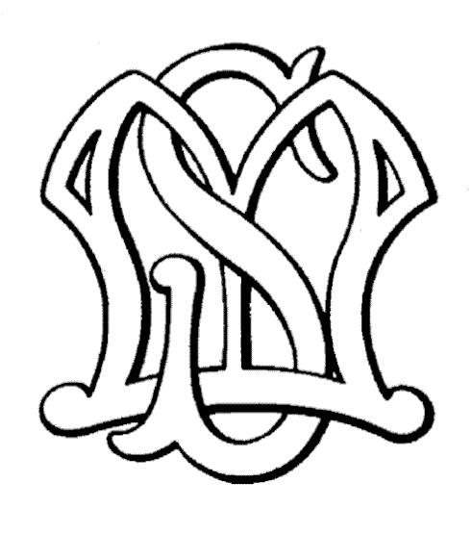
Website: www.societyofmary.net

Revised January 2015

